High Data Rate Transmission in High Resolution Radio Astronomy – vlbiGRID
Richard Hughes-Jones¹, Steve Parsley² , Ralph Spencer¹

¹ Dept. of Physics and Astronomy, University of Manchester, Oxford Rd., Manchester M13 9PL, UK
² Joint Institute for VLBI in Europe, (JIVE), Postbus 2 7900 AA Dwingeloo, The Netherlands

Abstract

Recent developments in Very Long Baseline Interferometry (VLBI) radio astronomy are aimed at improving reliability and reducing the cost of operations by moving from a custom made tape based system to using exchangeable disks in PCs. The advent of the iGRID 2002 exhibition in September 2002 with the availability of high data rate international links gave us the opportunity to try transferring the data via the internet. This would not only test the capacity of the links but also prove the viability of the use of the internet for VLBI. This development would also eventually lead to instant turn-around of VLBI data, which currently stands at several weeks. The tests were successful achieving data rates from Manchester of 500 Mbps over the production network. This was the first demonstration of fibre-optic link connected international VLBI.

Key words: Radio astronomy, VLBI, networks, ftp transfer, UDP packet stream, real time, High performance, High throughput, Giga bit data rates.

Introduction
New discoveries in astronomy have always followed improvements in instruments. The detail with which celestial objects can be studied is limited by both sensitivity and resolution. The relative importance of the two can perhaps be seen by comparing the high resolution and spectacular optical images produced by the Hubble Space telescope (2.4m diameter) [1], with higher sensitivity but lower resolution results from the 8-m diameter Gemini telescope [2] where the resolution is limited by fluctuations in the Earth’s atmosphere. In radio astronomy the atmosphere does not limit the resolution and the use of stable atomic clocks means that signals can be added coherently even if received by telescopes separated by the size of the Earth. The interferometer technique allows signals to be multiplied together from each pair of telescopes to give Fourier components. These can be transformed to produce images of the sky with much greater resolution than is possible with any optical telescope, even those in space. These instruments discovered Quasars and Radio Galaxies – objects situated at distances of Giga light-years - which radiate vast amounts of power via synchrotron radiation from relativistic electrons [3] in their active galactic nuclei.

The technique of using telescopes well separated on the Earth is known as Very Long Baseline Interferometry, (VLBI) and has been around since the mid 1960’s, the first system (the ‘MkI’) used 9 track computer tape at <1 Mpbs data rates. Techniques have improved with time, and the incorporation of new radio telescopes has led to routine VLBI operations world wide, with networks in the US, in the Asia-Pacific region, and in Europe.

VLBI enables us to study the angular structure of radio sources at resolutions as small as a millarcsecond. Several telescopes are required, typically involving around 10 telescopes so that a range of baselines is obtained and hence good coverage of Fourier components. In addition accurate positions of the telescope can be obtained, and this is used in geodesy and Earth rotation studies.

Coherence at each telescope is maintained by atomic hydrogen maser clocks accurate to 1 part in 10¹⁵. The Global Positioning System (GPS) of satellites is used to give absolute timing to an accuracy of 100 ns, more accurate timing comes from the astronomical data set itself. The radio frequency signals are converted into baseband in up to 32 channels, with 2 MHz or more bandwidth each before digitisation. The data are formatted, time stamped and then recorded onto 1 inch wide video tape on 18000 foot spools on modified commercial instrumentation recorders, at typical data rates of 128 or 256 Mbps. The data is on 32 tracks across the tape, each channel is independently time stamped and formatted into ‘frames’ of 22,500 bits. Parity bits are used to assess data quality, if more then 10% of the bytes have the wrong parity the frame is rejected. The MkIV [4] system is now in general use which uses broadband channels and can record continuously at up to 1 Gbps.

Unlike most other users of digital recorders, in VLBI the value of a single bit is negligible. The signal collected by the telescopes is broadband Gaussian noise. Useful information is extracted by correlating data from two telescopes to locate and characterise the signal that is common to both. This is revealed after averaging over many millions of samples. Errors in the data from one antenna are thus eliminated in the process. Error rates can therefore be high by normal communication standards, at 1 in 10⁵ bits or even occasionally 1 in 10⁴. Precise timing is of far greater importance however. The detailed structure and location of the radio source can only be deduced with a precise knowledge of the geometry of the antenna array relative to the celestial sphere. Where the telescopes were when each sample was collected is of vital importance. Time information is therefore recorded with the astronomical data and steps are taken to ensure its accuracy.

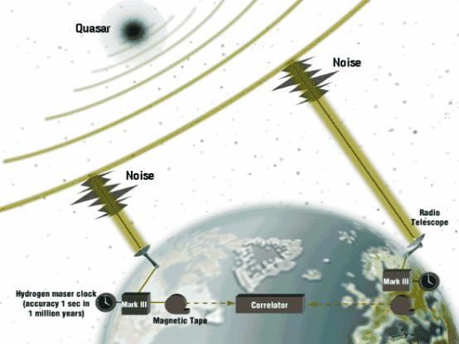
Figure 1.1 The concept of a Very Long Baseline Interferometer

The very nature of the Earth rotation synthesis technique requires the observations on each source to last several hours. Data are recorded continuously over each session (i.e weeks) except for short breaks for tape changes, telescope slewing and receiver changes. The total amount of data processed per session can be up to 10¹⁵ bits, with 10¹³ bits per tape. This is reduced by the correlator and subsequent processing to an image of a radio source of a few 100 Mbytes for perhaps every 8 hours of observation. The European VLBI Network (EVN) is an array of sensitive radio telescopes located in Germany, Italy, Poland, Spain, Sweden and the UK and extending to China [5]. We carry out VLBI observations during three sessions per year for a total of ~80 days per year, forming an interferometer with milliarcsecond resolution and high sensitivity. The network was established by a Consortium of radio observatories who operate the individual telescopes. Data from EVN VLBI observations are correlated in a central processor at the Joint Institute for VLBI in Europe (JIVE). The EVN often co-observes with the lower resolution UK MERLIN array and the US Very Long Baseline Array (VLBA).
The existing system for performing VLBI observations relies on shipment of the magnetic tapes to a central data processor. Historically this was the only practical way of moving the huge amounts of data involved. However the results are only known some weeks or months after the event. If anything went wrong it’s too late to fix it! Data rates of 256 Mbps are common, though tests at 512 Mbps have been made, but it has proved to be difficult to maintain performance of the expensive instrumentation recorders at high data rates. The sensitivity of VLBI increases as the square root of the data rate and so there is an ever increasing demand for the highest data rates.

As the current VLBI technology approaches the end of its development path the opportunity arises to make use of rapidly expanding data networks to connect the telescopes to the data processor in real time. This will improve reliability, give a more rapid turn round of results and in future lead to an increase in data rates and hence sensitivity. A step in that direction is the development of a disk based recording system. This is being pursued independently in Europe (PCEVN) and the US (MkV), with the aim of choosing the optimum system in the near future. PCEVN [6] takes the digital output of the MkIV formatter via the PCI bus. A custom made board in a PC running linux stores the incoming data streams to main memory arranged as ring buffers via DMA. The data can then be written to disk via a Raid0 system.

iGRID2002 23-26 September 2002 in Amsterdam gave us the opportunity to test links from the University of Manchester , through SARA Amsterdam and to the JIVE institute in Dwingeloo in the Netherlands, using real radio astronomy data recorded on the European disk based system (we in fact used the first data ever recorded on this system). The data were recorded at the Westerbork radio telescope in the Netherlands and the Jodrell Bank 25-m Mk2 radio telescope, some 30 km south of Manchester. Observations of the quasar DA193 were made in the afternoon of 12 July 2002, at an observing frequency of 5 GHz and at data rate of 256 Mbps in a test of the disk based PCEVN system. The normal magnetic tape system was used at Jodrell Bank, whereas the new disk based system was used at Westerbork. The exchangeable disks from Westerbork were later taken to a machine in the Regional Computer Centre in Manchester and connected into the national network, since there is only a 155 Mbps link into Manchester from Jodrell Bank Observatory at the moment.

Geant Core

SuperJANET4
Core
Network
NNW MAN
Manchester
VLBI
Source

VLBI
Analysis

Amsterdam
SURFnet
Core
iGrid2002
1 Gbit Eth.
2.5 Gbit Pos
10 Gbit
Figure 2.1Network Topology of the VLBI iGrid2002 Demonstration

Implementation of the Demonstration

Network Links, Topology and Hardware
Figure 2.1 shows the networks used in the VLBI demonstration, they are all production networks that carried normal user traffic during the demonstration. The VLBI data was sent from the server at Manchester, over the Net North West Metropolitan Network, MAN, and onto the UK Academic Network, SuperJANET4. Geant connected the UK with SURFnet, the academic network in the Netherlands, and this in turn was connected to the iGrid2002 Network with the server that acted as the data sink.

Both servers were supplied by Boston Ltd. (Watford UK) and used Supermicro P4DP6 motherboards with dual 2.0 GHz Zeon CPUs and the Intel E7500 (Plumas) chipset that provides 4 independent 64 bit PCI-X busses as well as separate EIDE DMA/100 interface and an on-board Ultra160 SCSI controller[7]. Boston Ltd donated two 10000 rpm Fujitsu MAN3367MC Ultra 160 SCSI disks that were configured as a Raid0 device and could transfer data at 100 Mbytes/s continuously. These were used to write the received VLBI data to disk at the iGrid2002 demonstration hall. Two Maxtor D740 7200 rpm EIDE DMA/133 disks were connected on separate EIDE buses and configured as a Raid0 device in the server at Manchester. Data could be read at 72Mbytes/s once the disk parameters were set with the hdparm command [8]
hdparm -c1 -d1 -u1 -m16 /dev/disk.

Data Format and Selection of Protocol
Figure 2.2 shows how the VLBI data appeared in memory. Each of the 32 bit positions in the computer word was associated with one of the digitised channels, as represented by the horizontal lines in the diagram. At the beginning of each Data Track Frame, the digitiser and formatter outputted a frame marker, and time-stamped each channel using the maser time reference. The data in each channel of a Data Track Frame contains parity information, so that errors could be detected. There were about 7.1 UDP packets per Data Track Frame.

Bit Streams
Timestamp
Data
Data Track Frame
~ 7.1 UDP Packets / Data Track Frame
32 bit words bits vertical
Figure 2.2 Data format and the relation between the sampled data bit streams that form the Track frames, the computer words, and the UDP packets.

The fact that at any given time, the VLBI data represents noise from the selected object in the sky implies that no portion of data is more important than any other. Thus loss of data, by packet loss for example, is not important so long as it is known that data has been lost and subsequent data is in the correct position in the data stream. A bad packet will probably only result in 1/7 of the frame being in error. Of this approximately half will have the wrong parity so the 10% threshold may not be crossed and the frame will be accepted for correlation. This is true even if the packet loss wipes out the header because the replay system flywheels over bad headers so long as the next header comes up in the right place in the data stream. It is the correlation process itself that rejects the bad data because it only occurs in the data from one telescope. This approach makes the Mk IV format ideal for network transfers.

The TCP/IP protocol provides bit-wise correct transport of data over a network, however, the loss of a single packet is interpreted as an indication of network congestion and the transmission rate is reduced by half [9]. This has a dramatic impact on the useful throughput that can be achieved on high bandwidth long distance paths, for example: for a 1 Gbit/s link from Manchester to Amsterdam (rtt ~15ms) it would take 94s to utilise the network at full capacity after the loss of just 1 packet [17]. There is current research in progress to improve this behaviour [10]. The difficulties with TCP/IP, together with the properties of the VLBI data and the need to transmit data continuously at high rate (250Mbit to 1Gbit/s) in real time provided the rational for using UDP as the transport method. In the near future it is envisaged that data will be sent directly from the digitisers to the correlator without use of intermediate disks. It was decided to test sending data as a simple stream of UDP packets, which is suitable when there is low packet loss on the network. Future work will also investigate using UDP with packet loss correction, such as RUDP [11]. Rather than use a RTP header[12], which is more appropriate for transporting audio visual data, a simple application header was used to provide packet sequence number and a time-stamp that was filled in when the data was sent.

Data Moving Software
Figure 2.3 shows a block diagram of the functionality required to send the VLBI data from Manchester to Amsterdam. The operation of the data server program, ast_send, at the telescope site (Manchester) was instructed by commands sent from the data reception program, ast_recv, at the correlator site (iGrid2002 for this demonstration). The demonstration was controlled from a Web page which was interfaced to the data reception program; so commands flowed from the web page to the data reception program and on to the data server.

The data had been digitised at the telescopes and recorded in binary format on standard Unix 1.8 Gbyte files. Once the server had been instructed to send data, the ast_send program read data from the requested file into a ring-buffer and then transmitted the data onto the network as stream of UDP packets. The packet sequence number in the application header was incremented by one for each packet sent. The time between successive UDP packets was carefully controlled using timing derived from the CPU cycle-counter. This method was used to reduce the possibility of creating unacceptable bursts of packets on the network. Measurements indicated that data could be efficiently read from the file and placed in the ring-buffer using fixed length 20 kbyte blocks. Data was extracted from the ring-buffer in 1452 byte sections, which was the maximum size that could be placed in an Ethernet packet after allowing for the level2 framing, IP, UDP and application headers. Only the last packet sent for a given transfer might have a smaller payload.

Raid0
Disc
UDP Stream Data
Raid0
Disc
RingBuffer
RingBuffer
TCP Control
ast_web Interface
Web Page
ast_recv
ast_send
Figure 2.3 Schematic representation of the operations performed to move the VLBI data.

The data reception program, ast_recv read the UDP packets from the network, placed them in a ring-buffer and wrote the information to disk. As explained in Section 2.2 each packet had an application header containing control information followed by the VLBI data. When a packet was read from the network, the application header was placed directly into a control area and the VLBI data was put into the ring-buffer, thus avoiding any extra data moving. Figure 2.4 shows how the data was placed into the ring-buffer. It was assumed that the UDP packets arrived in order and that none were lost, i.e. data from consecutive packets were put into consecutive memory slots in the ring-buffer. Once the data were in the ring-buffer, the packet sequence number in the header was inspected and if this did not correspond to the memory slot, the data were moved to correct location.

As well as incrementing the packet sequence number in the application header, ast_send also time-stamped the outgoing packet with the time from the CPU cycle-counter. ast_recv also time-stamped each packet it received and stored both times. The information from a few thousand packets was first stored in memory and recorded on disk at the end of each data transfer. When each data file had been opened by ast_send, a simple request-response sequence was used to synchronise the times derived from the CPU cycle-counters on the sending and receiving systems. It was not intended that the synchronisation would be absolute like GPS synchronised systems, but that network performance during the data transfers could be investigated by examining the variations in the 1-way delays of the packets.

Initially a UDP control channel was used. This used a request-response handshake with timeouts to ensure that the commands were correctly sent over the network. This approach worked well for obtaining statistics from the remote system, and for giving commands when the network was lightly loaded. However it gave undesirable results when the response was lost for commands that should only be executed once, such as the “start sending data” command – data could already be streaming though the network when subsequent “start” commands were received. For this reason, a separate TCP/IP channel was used to control the distributed application.

Time
In-coming
packet ids
1
2
3
4
6
1
2
3
4
Move 6
Continue with 7
Figure 2.4 The steps involved in receiving packets and placing data into the ring-buffer.
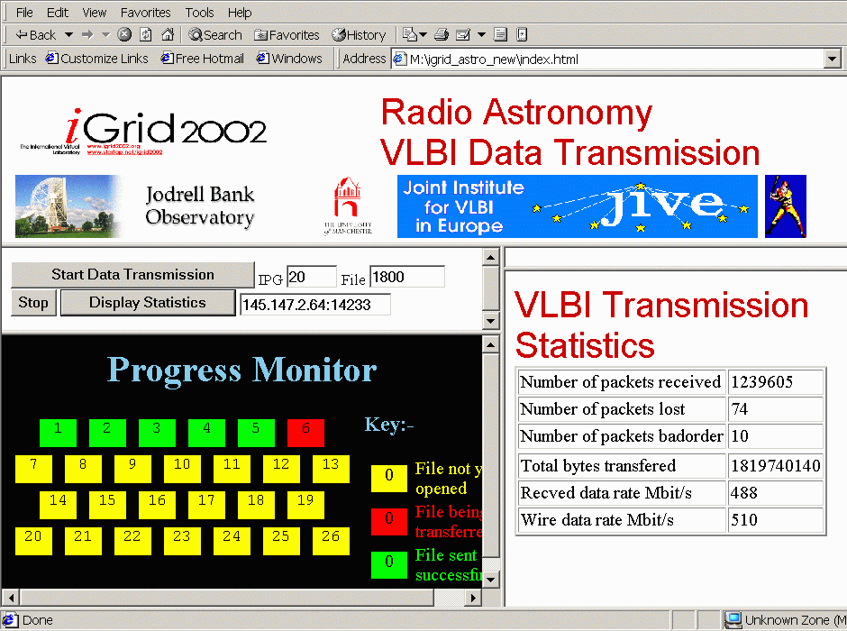
Figure 2.5 Screenshot of the Web page used in the demonstration

The Display and Control Software
The demonstration was designed to use a web page for control and display of the status and progress of the data transfers, a screenshot is shown in Figure 2.5. The Progress Monitor frame showed the 1.8Gbyte files of VLBI data waiting to be opened as boxes coloured yellow. This changed to red when the file was being transferred and to green when the file had been successfully transferred. When each file had been transferred, statistics of that transfer were retrieved from the receiving program, formatted and displayed in the Transmission Statistics frame on the right of the web page.
The Web page consisting of the framesets, control buttons and icons was read from a conventional web server, but the commands attached to the control buttons had to be sent to the ast_recv program shown in Figure 2.3, and as the data was transferred, status information had to be returned to the browser. Normally it is the user that requests information, but here it is the ast_recv program that knows when there is valid status information to send. Rather than needlessly poll, a simple “web server” program, ast_web in Figure 2.3, was written to listen for http requests from the demonstration web page. To avoid confusion, ast_web used TCP port 14233, not the normal port 80. The operation was as follows. The control buttons made http GET requests for the relevant command eg “GET start.html”; ast_web parsed the http and forwarded the commands to the data moving programs. To allow the display of progress and status information, on receiving “GET start.html” ast_web returned some Javascript to a hidden window to make a new http request for “GET next.html” and then closed the current http link. When a “GET next.html” request was received, ast_web held the link to the browser open until there was some information to display. At which time, the display information was sent together with the Javascript for a new “GET next.html” request. Closing the link to the browser after sending each status update, ensured that the display was updated.

Results
Figure 3.1 shows plots of the UDP transfer rate, the number of packets lost and the number of re-ordered packets for a set of VLBI data files transferred during the first demonstration on Tuesday 24th September 2002. Each data file was 1.8 Gbytes long and was sent using 1.24 million packets each with 1452 bytes of user data. Two transfer rates are shown in the upper graph, the lower points being the VLBI data rate and the upper points represent the actual rate on the physical medium, allowing for all the networking and framing headers. The 515Mbit/s rate was determined by selecting the time between transmitting packets to be 20 µs. Normally during the demonstration, about 40 - 50 packets were lost per transfer, but occasionally much larger losses were incurred. Packet loss was heavily dependent on other transfers or cross traffic along the networks between Manchester and Amsterdam, and such losses are to be expected when the load on the network links approached 70% - see Figure 3.4 below.

Study of the packets that arrived with their sequence numbers “out of order” showed that these packets had been overtaken by the previous packet that had been sent. This effect has not been seen on tests made on the UK academic network SuperJANET4, nor on SURFnet. As no multiple trunk links have been deployed in the networks that were used, this re-ordering effect is believed to be due to the use of parallel forwarding engines in the Juniper M150 routers used in Geant. It is likely that there is some threshold in the traffic load above which re-ordering may take place, see [13] for a discussion on re-ordering.

Figure 3.2 shows the corresponding plots taken during the Thursday demonstration that coincided with the Maximum Bandwidth Attempt at iGrid2002. During this Bandwidth Attempt, a total traffic level of 6.9 Gbit/s was recorded passing through the core router at iGrid, which was close to the maximum of 8Gbit/s possible between the 10 Gbit Ethernet interface and the router backplane. This helps to explain the dramatic rise in the number of lost packets, from 40-50 to 5000-12000, which is clearly not very helpful for the transfer of VLBI data. The number of packets out of order also increases from ~20 to ~50 per transfer, this could be due to the increase of traffic from Geant into iGrid or just changes to the traffic pattern on the Geant core.

During iGrid2002, the basic network performance for end-to-end UDP traffic was
measured using UDPmon [14]. This tool was used to transmit streams of UDP packets at regular, carefully controlled intervals and the throughput was measured at the receiver. Figure 3.3 shows a plot of the throughput obtained for various packet sizes. On the right hand side of the plot, the curves show a 1/t behaviour, where the delay between sending successive packets is most important. On an unloaded network UDPmon will measure the Capacity of the link with the smallest

Figure 3.1 Upper Plot: Graphs of the user and “wire” data transfer rates for a series of 1.8 Gbyte data transfers, each sending 1.24M packets, taken during the first demonstration. The lower plot shows the corresponding number of packets lost and the number that arrived out of order.

Figure 3.2 Upper Plot: Graphs of the user and wire data transfer rates for a series of 1.8Gbyte data transfers taken during the iGrid2002 Band Width attempt. The lower plot shows the corresponding number of packets lost and the number that arrived out of order.

Figure 3.3 UDP transfer rates from Manchester to iGrid Amsterdam taken on Tuesday morning using UDPmon. The “wire” rates include UDP, IP headers and Ethernet Framing overheads.

bandwidth on the path between the two end systems. On a loaded network the tool gives an estimate of the Available bandwidth [15], this being indicated by the flat portions of the curves. (As the packet size is reduced, processing and transfer overheads become more important and decreases the achievable data transfer rate. The Available bandwidth, ie the data rate possible on the medium is not affected by the processing overheads. This is also true for systems directly connected back-to-back.) Inspection of Figure 3.4 shows that on Tuesday afternoon, when the UDPmon tests were made, the average traffic level on the 1 Gbit link between Manchester and SuperJANET4 was ~300 Mbit/s, in agreement with the 700 Mbit/s reported by UDPmon. This test and others made prior to iGrid2002 indicated that UDP transfers of VLBI data should be possible.

Figure 3.4 shows a plot of the network traffic from the SuperJANET4 access router at Manchester recorded with MRTG. The normal diurnal traffic levels for the Net North West MAN vary between 70 and 300 Mbi/s into the MAN (solid graph) and between 200 and 400 Mbit/s out of the MAN (line graph). The 500 Mbit/s VLBI traffic for iGrid2002 is visible as the sharp spikes, which occur while the demonstration was being tested or was in progress. Depending on the background level, the transmission of the VLBI data takes the outgoing traffic level to 650 to 700 Mbit/s, or 65 to 70 % of the access links of Manchester University to Net North West and to SuperJANET4. It is worth noting that the 500 Mbit/s VLBI traffic corresponds to 20% of the SuperJANET4 and SURFnet access links to Geant as well as 20% of the capacity of the Geant Core network between the UK and Netherlands.

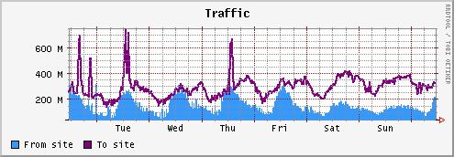
To NNW
From NNW
Traffic Mbit/s
Figure 3.4 Plot of the traffic levels from the SuperJANET4 access router at Manchester for the Net North West MAN during the iGrid2002 meeting.

As discussed in section 2.3, instrumentation in the data transfer programs provided information on the network performance during the data transfers. A typical plot of the arrival time and the one-way latency of each packet is shown in Figure 3.5. It is the relative times that are of interest, i.e. the time-zero of the arrival times is determined when the file-open command is given, in this case ~5s in advance of the measurements. The one-way delays are not absolute as they assume that the routing (and delays) between the end systems is symmetric. The Packet arrival times show a series of steps occurring approximately every 60 packets or ~1ms. The slope of the arrival times gives the transfer time per packet and the fitted line corresponds to a data transfer rate of ~475 Mbits/s, in good agreement with that reported by the demonstration display, which in this case was 493Mbit/s. The slopes of the individual segments correspond to a data rate of ~1.1Gbits/s – much greater than the rate data was placed on the network. This behaviour is an indication of interrupt aggregation by the network interface. Data is placed into memory as it arrives from the network but the CPU is only interrupted after so-many packets have arrived or a timer on the network interface has expired. The one-way times confirm this, with latencies that are longer for packets that have had to wait longest for the next interrupt to occur. The variations in the one-way latencies occur when there are steps in the receive times and the magnitude of the variation ~1ms corresponds to the times between interrupts. Besides this behaviour, the plot shows little evidence for queuing on the network itself.

.

Figure 3.5 A typical plot of the arrival time and the one-way latency of each packet. All times are in µs

Correlation of data sent to JIVE
During iGrid2002, the link provided by SURFnet between Amsterdam and Dwingeloo became operational. Data from Manchester were sent by ftp to Dwingeloo, received via a Gigabit Ethernet connection and copied onto disks in a PCEVN system. The data were then transferred to the correlator via a standard VLBI station unit originally designed for use with the MkIV magnetic tape playback machines. At this point the disks then contained copies of the original data recorded using the Westerbork telescope, which had been transmitted (in reverse to the normal direction) from Manchester. At the same time the tapes from Jodrell Bank observatory were played back on another playback machine, synchronised with the disk based system and fed into the correlator. Figure 4.1 shows the results from the correlator. The correlator cross multiplies the signals (in phase and quadrature) for a range of relative time delays, averages for 2 seconds and produces plots of the correlation coefficient. The plots show the amplitude as well as real and imaginary parts of the correlation coefficient. The peak at a relative delay of 33 clock periods shows that the fringes were clearly detected from DA193 and that the data were of good quality.

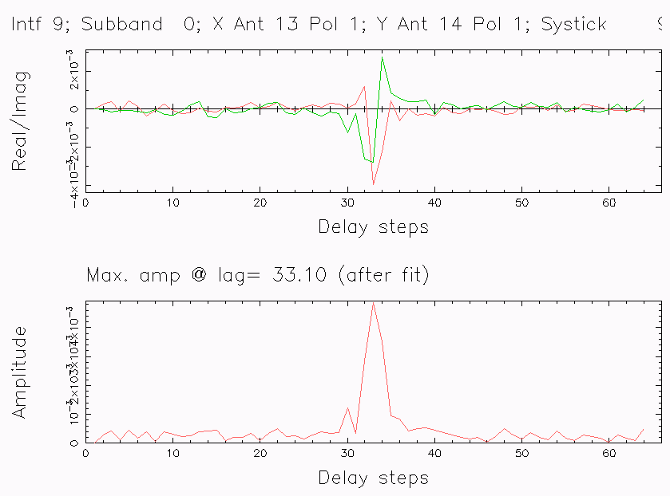
Figure 4.1 Plot of the correlation coefficient vs delay for the JIVE correlator.

This was the first demonstration of international VLBI using fibre-optic connected links. A previous experiment, carried out in 1977, was at low data rates between the US and Canada [16]. Successful fibre linked experiments between Japan and Finland (Ritakari priv. comm.) and Japan and the USA (Whitney, priv. comm.) carried out in October 2002 have just been announced.

Conclusions and Lessons Learnt
We believe that the iGrid2002 demonstration showed “proof of concept” that the production network can be used to transfer VLBI data at ~500Mbit/s using a simple UDP based protocol. The packet loss was acceptable provided that none of the links involved were close to saturation. The end-to-end links involved include:
- Telescope digitiser and correlator to campus backbone
- Campus to MAN
- MAN to NRN
- Access links between the NRNs and Geant
- Geant Backbone.

However as VLBI data rates increase and the number of telescopes that use the network at access the correlator increases, special provision must be made for this traffic on the entire network. SURFnet for example have already installed WDM equipment at SARA (Amsterdam) and JIVE (Dwingeloo) to provide three separate optical links. Initially these will operate as Gigabit Ethernet. As more telescopes in different countries are connected, it seems likely that the Geant access link for the Netherlands and even the Geant Core Network will have to be upgraded.

Due to the construction of the core routers in the Geant backbone, packets may be re-ordered, usually only by 1, and the data moving software should correct for this to reduce the number of “lost” packets.

There is a clear advantage in having separate control/monitoring and data moving channels over the network.

The VLBI Demonstration confirmed that the end hosts must have sufficient power in both compute cycles and input/output capability. An initial specification would include:
- 64bit 67MHz PCI bus
- 2 GHz processor
- Gigabit Ethernet interface (Intel Pro 1000 was used but others such as SysKonnect have been tested and work well).
- Fast disks with high speed buses configured in a Raid0 configuration. (The Demonstration used 2 Maxtor D740 EIDE 133 in Raid0 for reading the data for transmission and 2 Fujitsu MAN3367MC Ultra 160 SCSI disks, donated by Boston Ltd., for writing the data. Both systems performed as expected from the specifications.)
- Modern Operating system and efficient IP stack

We believe that this was the first time that VLBI data has been successfully recorded at Radio Telescopes in different countries and transferred over the production internet to the correlator.

Acknowledgements
We wish to thank the following colleagues for their help and support in the preparation for this iGrid2002 demonstration:
- Boston Ltd & Supermicro for the supply of the Supermicro servers and the donation of SCSI disks - Dev Tyagi (Supermicro), Alex Gili-Ross(Boston)
- Brunell University - Peter van Santen
- JIVE and ASTRON – S. Pogrebenko, A. Szamuru, M. Leeuwinga, K. Stuurwald, H. Vosmeijer, H. Verkouter, M Nijk, M. Garrett
- Metsähovi Radio Observatory – A. Mujunen, J. Ritakari
- SURFnet & Universiteit van Amsterdam - Pieter de Boer, M. Nijk, Erik.Radius, Cees de Laat, Mieke van de Berg
- UKERNA - Robin Arrack, Bob Day, Jeremy Sharp
- University of Manchester - Paul Burgess, Pat Meyers
- Robin Hughes-Jones Design of web interface (Undergraduate, Oxford University)

References
[1] Gallery of Hubble Images http://hubble.stsci.edu/gallery/

[2] The Gemini Photo-Gallery – Science Images http://www.gemini.edu/gallery/science/

[3] An Atlas of DRAGNs http://www.jb.man.ac.uk/atlas/

[4] Memos on the MkIV system are to be found at http://www.haystack.edu/vlbi/vlbisystems.html

[5] Very Long Baseline Interferometry in Europe http://www.jive.nl/
[6] Ritakari, J., and Mujunen, A., ‘The Metsähovi Solution for Gigabit VLBI’, IVS CRL Tech. Dev. Center News, No. 20, June 2002.

[7] Supermicro motherboard reference material
www.supermicro.com and www.supermicro.com/PRODUCT/MotherBoards/E7500/P4DP6.htm

[8] hdparm disk and controller parameters:
-c1 Use 32 bit I/O
-d1 Use PCI bus master I/O instead of processor driven I/O
-u1 Ensure IDE interrupts do not hinder processing of other interrupts.
-m16 Use the low level IDE capability to transfer multiple sectors in 1 command.

[9] W.R. Stevens “TCP/IP Illustrated Vol1&2” Addison-Wesley

[10 ] IETF Internet Draft “Highspeed TCP for Large Congestion Windows” Sally Floyd
www.icir.org/floyd/papers/draft-floyd-tcp-highspeed-00c.txt Contact R.Hughes-Jones@man.ac.uk for an implementation.

[11] E. He, Leigh, J., Yu, O., DeFanti T. A., Reliable Blast UDP : Predictable High Performance Bulk Data Transfer, IEEE Cluster Computing 2002, Chicago, IL 09/01/2002 - 09/01/2002.

[12] RFC1889 “RTP: A Transport Protocol for Real-Time Applications”

[13] M. Laor, L.Gendel “The effect of Packet Reordering in a Backbone Link on Application Throughput” IEEE Network Sep 2002

[14] UDPmon R. Hughes-Jones A tool for investigating network performance. Writeup and tool available from www.hep.man.ac.uk/~rich/net .

[15] For definition of the terms used here, see GGF NM-WG draft L. Cottrell, R. Hughes-Jones, T. Kielmann, B. Lowekamp, M. Swany, B. Tierney “A Hierarchy of Network Measurements for Grid Applications and Services”
www-didc.lbl.gov/NMWG/measurements.pdf

[16] Yen, A., Kellermann, K., Rayhrer, B., Broten, N., Fort, D., Knowles, S., Waltman, W., Swenson, G., 1977, Science 198, 289
$ρ=\frac{C∗{\text{RTT}}^{2}}{2∗\text{MSS}}$[17] The time to go back to using a network link at full capacity after experiencing a loss is given by:
Where
C is the capacity of the link
RTT is the round trip time
MSS is the maximum segment size
See .P. Martin-Flatin and S. Ravot. “TCP Congestion Control in Fast Long-Distance Networks.” Technical Report CALT-68-2398, California Institute of Technology, July 2002
http://datatag.web.cern.ch/datatag/publications.html
Authors:


Richard Hughes-Jones leads development of the Grid and Trigger/Data Acquisition systems in the Particle Physics group at Manchester University. He has a PhD in Particle Physics and has worked on Data Acquisition and Network projects for over 20 years, including evaluating and field-testing OSI transport products. His interests are in the areas of realtime computing and networking within the context of the ATLAS experiment in the LHC programme including the performance, network management and modeling of Gigabit Ethernet components. Within the Global Grid Forum he is co-chair of the Network Measurements Working Group. He is secretary of the Particle Physics Network Coordinating Group which has the remit to support networking for PPARC funded researchers. Within the UK GridPP project he is deputy leader of the network workgroup and is active member of the EU DataGrid networking workpackage (WP7). He is also a PI in the EU DataTAG project and involved in the UK MB-NG project to investigate QoS and various traffic engineering techniques. He is currently investigating the performance of transport protocols over LANs, MANs and WANs

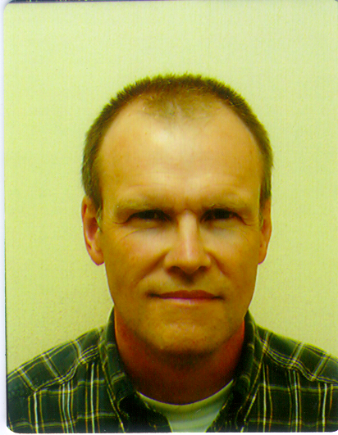

Steve Parsley is Head of Technical Operations at the Joint Institute for VLBI in Europe (JIVE) in the Netherlands. His involvement in Radio Astronomy began in 1993 when he joined Penny & Giles Data Systems Ltd. in Wells, UK. There he managed several projects developing and manufacturing data acquisition and recording equipment for the VLBI community. Before this he worked in the UK defence industry developing airborne display and data recording systems for military aircraft. This included holographic heads-up displays for General Dynamics F16 and compact, multiplexed video recording and replay equipment for Tornado. Steve is a Chartered Engineer, Member of the Institution of Electrical Engineers and registered with FEANI as a European Engineer.

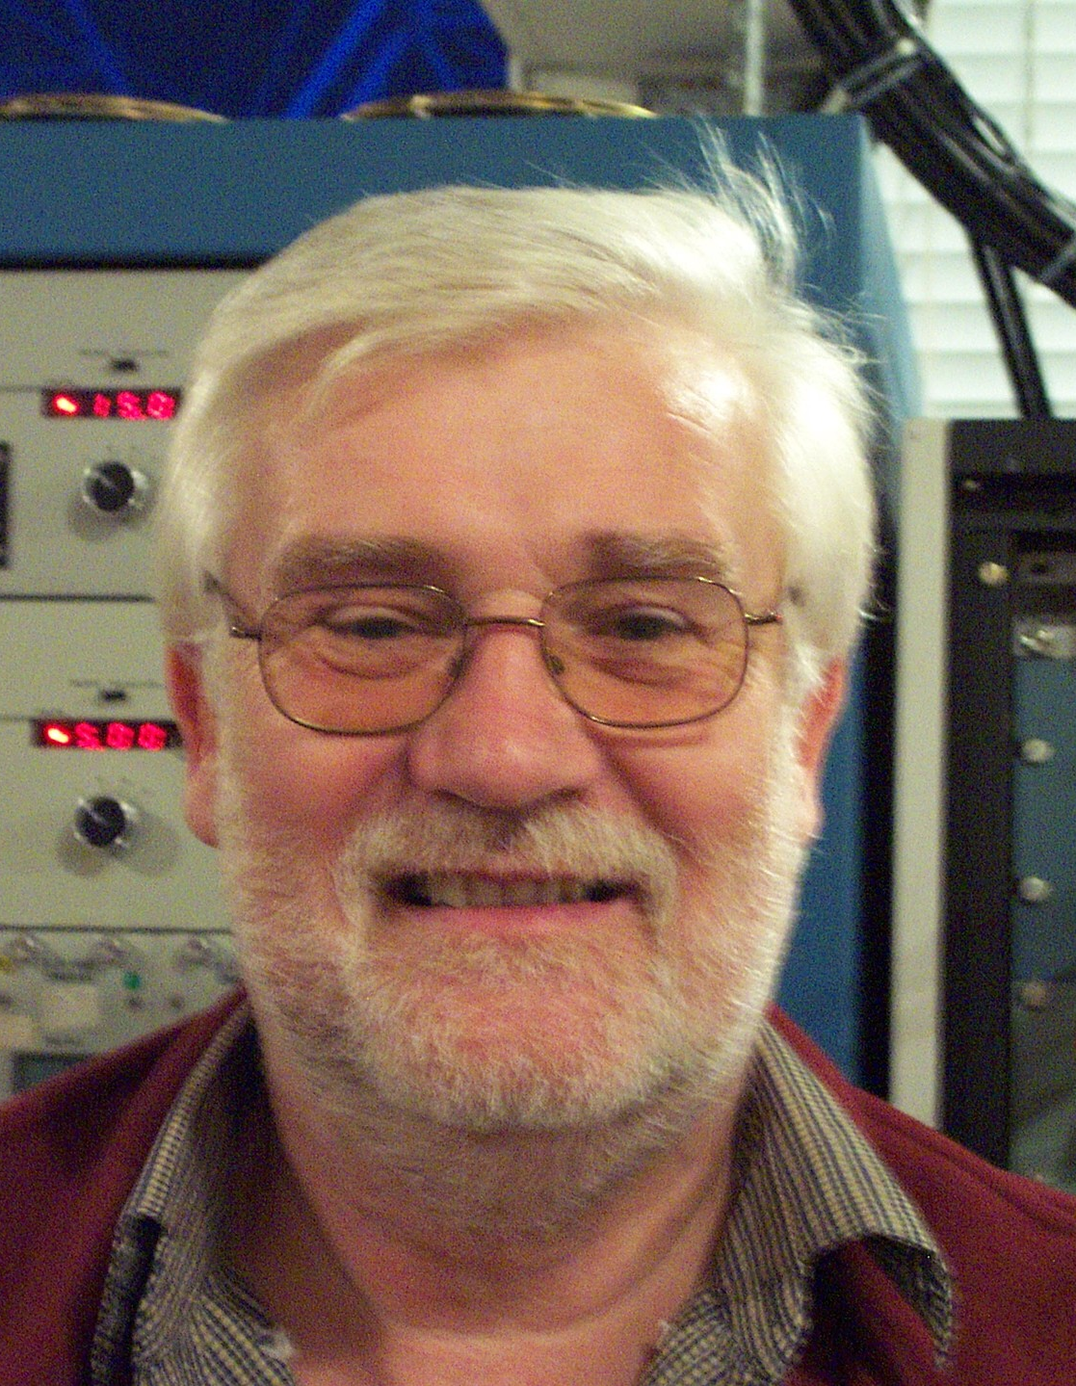

Dr Ralph Spencer is Reader in Radio Astronomy at the University of Manchester. He has worked on the development of interferometers for radio astronomy since the 1970’s, leading work on the development of phase stable radio linked interferometers with 100 km baselines. This work led to the development of the MERLIN array of 7 telescopes now operated as a National Facility by the University of Manchester for PPARC. His interest in VLBI started in the late 1970’s and was responsible for running VLBI operations at Jodrell Bank Observatory until the mid 1990’s, when the National Facility took over. European development of the 1 Gbps MkIV VLBI system was led by him until 2001, and this is now in routine operation world wide at data rates up to 256 Mbps. His astronomical research interests include studies of microquasars. These are radio emitting X-ray binaries in our own galaxy which emit jets of matter at relativistic velocities. They act as laboratories for the study of the formation of jets in general, a topic which is great relevance to the study of quasars and radio galaxies in general. Ralph is a Fellow of the Royal Astronomical Society and a Member of the New York Academy of Sciences.

